|  |  |
| --- | --- |
| **Department:** | Parks & Recreation |
| **Supervisor:** | P&R Director |
| **Prior Revision Date:** | 3/06/2018 |
| **Last Revision Date:** | 3/16/2021 |
| **Revision Made By:** | S Payne |
| **Revision Reviewed & Approved by:** | S. Giesbrecht |
| **Employment Status:** | PMEA Union |
| **Date Provided to Bargaining Unit** | 3/16/2021 |

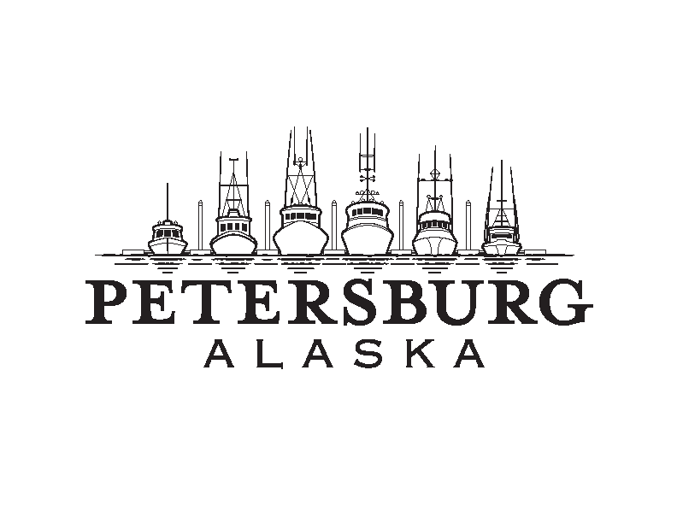

**City of Petersburg**

**Job Description______________**

**Job Description_______________________________**

**PARKS AND RECREATION**

**PARKS ASSISTANT**

**Definition**

The Parks Assistant is a member of the Parks and Recreation Departmental team utilized on a seasonal basis to provide general care and maintenance of Borough grounds, including cemetery, parks, playgrounds, shelters, greenbelts, planters, plants and trees; and performs general care of recreational facilities and parks.

**Supervision Received**

The Parks Assistant reports directly to the Parks and Recreation Director and may take direction from the Groundskeeper.

**Supervision Exercised**

None.

**Duties** *(The duties listed in this section are intended as illustrations of the various types of work that may be performed. The omission of specific statements of duties does not exclude them from the position if the work is similar, related or a logical assignment to the position.)*

The Parks Assistant assists in the following:

Maintaining cemetery grounds; including mowing, raking, weeding, fertilizing, planting, seeding, pruning, thinning, etc.;

Participation in funeral preparation and conclusion. Includes placement of boards and frame, removal of sod, removal of dirt, trimming of grave, placement of box, ropers, grass, etc. Replace fill and sod, clean area and maintain to blend.

Cleaning of park facilities;

Cleanout of ditches

Performing maintenance work, as required, in support of and in preparation for recreational programs or activities;

Landscaping and grooming tasks, such as: maintaining park areas, trees, flower boxes, hanging baskets, and hedges throughout town;

Painting or staining facility apparatuses; and

Performing other duties as assigned.

**Distinguishing Characteristics**

The work assigned to the Parks Assistant is characterized by the diversity of tasks performed. This person is required to have tactful customer relations skills with people of all ages. The position requires that the person perform the great majority of their work in the outdoors, frequently under adverse weather conditions. The person in this position needs to understand verbal directions and work with minimal supervision.

**Working Conditions**

The employee in this position performs duties outdoors and is exposed to a variety of weather conditions. The employee must be skilled in the safe operation of lawn mowers and hand tools. The position comes in frequent contact with the general public of all ages. The person in this position must have the ability to lift up to 25-50 pounds on a regular basis and be available to work weekends and nights, dependent on the department’s needs.

**Qualifications**

Must possess a current and insurable Alaska State Driver’s license.

Any combination of experience and education which provides the applicant with the following attributes:

Grounds maintenance, gardening and lawn care;

Ability to safely operate a variety of small equipment;

Ability to work in adverse weather conditions;

Ability to work with minimal supervision;

Ability to safely operate power tools, including mower, edger and chainsaw;

Ability to recognize limitations and consult with resources for answers;

Ability to establish and maintain a positive relationship with the community;

Must be accurate, dependable, neat and thorough in assigned tasks;

Must be able to keep work areas neat and clean;

Ability to establish and maintain effective working relationships with fellow employees; and

Work cooperatively with supervisors and display willingness to assist co-workers.

**Signatures affixed on this job description confirm that it has been reviewed by the employee and his/her direct supervisor and that a clear understanding of the expectations of this position exists.**

**______________________________ ______________________________**

Employee Supervisor

**_________________ ________________**

Date Date